

**An Overview of Sustainable Practices at Agastya Academy**

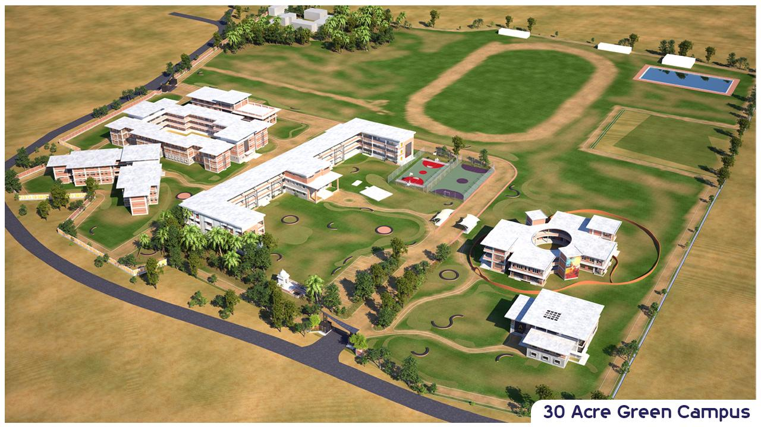

Agastya Academy is nestled within a 30-acre green campus where every brick laid and every initiative undertaken resonates with a commitment to environmental stewardship.Everyaspect of our institution reflects a deep commitment to sustainable practices, from the materials used in construction to our agricultural methods and waste management systems. In this blog, let's get into the various initiatives that define Agastya Academy's harmonious relationship with nature.

[Click Here for information…….](https://www.agastyaacademy.edu.in/post/an-overview-of-sustainable-practices-at-agastya-academy)